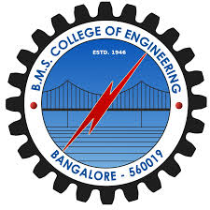BMS College of Engineering, Bangalore – 19

Department of Electronics and Communication Engineering

<Project Title e.g., Smart Irrigation>

<Students names e.g., Dinesh Reddy J, Ravikumar, Laxmi Narayan, Radha Krisha>

<Implementation>

<Abstract>

<Proposed solution / Block diagram>

<Signature of the guide>

<Results>